| 12. ReactJS-HOL |
| --- |

* Conditional rendering in React refers to the process of showing or hiding parts of the UI based on certain conditions, such as whether a user is logged in or not. Just like JavaScript allows if-else logic, React allows you to render different elements or components based on conditions using techniques like if-else statements, ternary operators, logical && operators, or switch cases.

* Element variables in React are variables that can store JSX elements. These are used to conditionally assign different elements to a variable and then return that variable in the render method. For example, based on a condition, you might assign either a <Login /> or <Logout /> component to an element variable and render that accordingly.

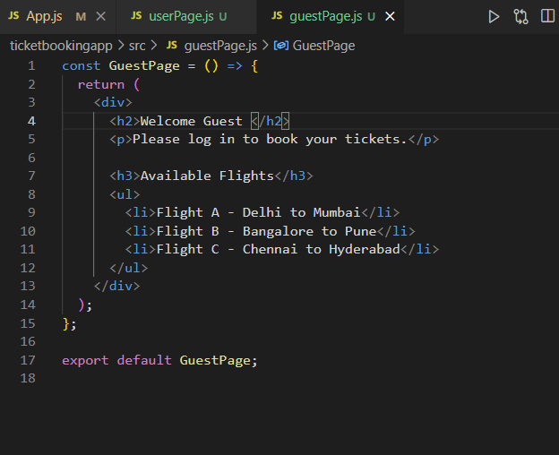

* To prevent a component from rendering, you can return null from its render method or from within a functional component. Returning null tells React to skip rendering that component, which is useful when you only want to display something under specific conditions without affecting the rest of the UI.

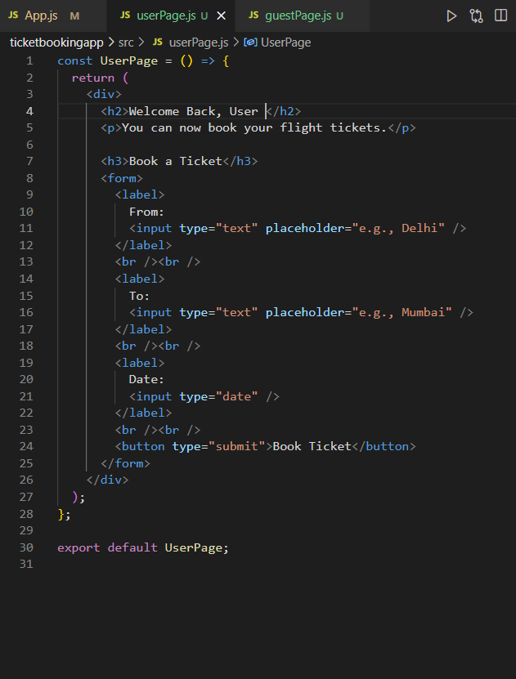

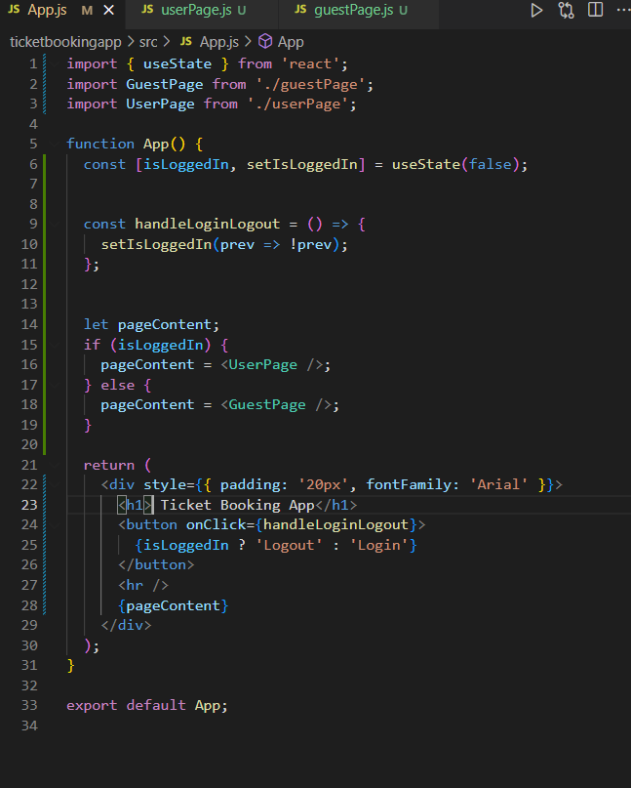

**Output**

